Ennismore Minor [www.ennismoreeagles.com](http://www.ennismoreeagles.com)

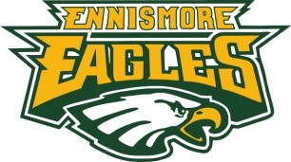

Hockey Association

P.O. Box 138

Bridgenorth, Ontario

K0L 1H0

**PLAYER CODE OF CONDUCT**

!

The EMHA Executive, volunteers, coaches and others have all made a commitment to making this season a successful one. The most important commitment though, comes from the players themselves, in time, effort, attitude and behaviour. Your success in hockey and in life is determined by the decisions that you make and the accountability that you take for your actions. As an Ennismore Eagle Hockey Player, I understand and acknowledge the following rules that form the:

**Player Code of Conduct**

**1)** I understand that the participation in EMHA Hockey is not a right – it is a privilege.

**2)** I will treat everyone involved in the EMHA fairly, regardless of age, colour, sexual orientation, religion, gender and place of origin.

**3)** I realize that any type of bullying/harassment is completely unacceptable. Examples of bullying are:

i) Physical – hitting, slapping, punching, pushing, staring. ii) Verbal – name calling.

iii) Cyber – posting inappropriate comments or pictures on the internet.

**4)** I will maintain self-control at all times. I will refrain from demonstrations of frustration or anger after a penalty or game loss. I will avoid unnecessary or exaggerated celebration of a goal scored or a game won that would embarrass the EMHA or demean the opposing team.

**5)** I will keep in mind that when at an EMHA function I am representing not only myself but also the Ennismore Eagles, EMHA, The Village of Ennismore & SELWYN Township and are expected to act in an appropriate manner.

**6)** I will show respect for my teammates, opponents, coaches, management, referees and timekeepers.

**7)** I will follow the rules laid out by Team Management (ie: dress code, before game arrival time).

**8)** I will be respectful of all arenas that I am in, especially the dressing rooms.

**9)** I will report violations of this code to team management/coaches.

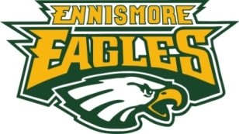

**Ennismore Minor Hockey Association**

**Player Code of Conduct Agreement**

**Possible Consequences of EMHA Player Not Respecting The EMHA Code of Conduct**

Player consequences depend entirely on the nature, duration and intensity of the player’s inappropriate action(s).

EMHA believes in progressive discipline that encourages open communication, no surprise consequences and promotes positive player actions and relations.

**Examples That Reflect Progressive Discipline**

1. Team meeting between coaches (or Executive) and all players going over Player Code of

Conduct)

2. Players sign Code of Conduct. Players under the age of 18 require an adult signature.

3. Discussion between coaching staff and player (possible parent involvement) if rule broken.

4. Loss of ice-time during a game.

5. Player removed from practice, game, team event.

6. Player asked to stay away from team events for 1 week.

7. Player removed permanently from team.

I!will!follow!all!of!the!rules,!regulations!and!codes!of!conduct!that!are!outlined!by!the!OMHA![(www.omha.ne](http://www.omha.net)t)!and! Hockey!Canada![(*www.****hockeycanada****.ca*](http://www.hockeycanada.ca)*)*!websites

**Signed By Players Novice Age and Above**

Player’s Name: _________________________ Age: __________________________

Hockey Level: ___________________________ Signature: ___________________________

Parent/Guardian Signature: ___________________________

**(For Players Under 18 yrs of Age)**

***Updated March 2014***!